June 2022

Name of the Activity: Annual Training camp

Date: 15 jun - 24 june 2022

Organised by : 3 Andhra girls BN NCC, KAKINADA

Discription : State level Annnual Training Camp held at JNV Peddapuram from 15 jun - 24 june 2022 organised by 3 Andhra girls BN NCC Kakinada unit for this camp opur seniour cadet N.Manasa Reg No. AP20SWA631007 selected from our college on behalf of 6 Andhra girls BN Anantapur unit. She is successfully completed the camp .

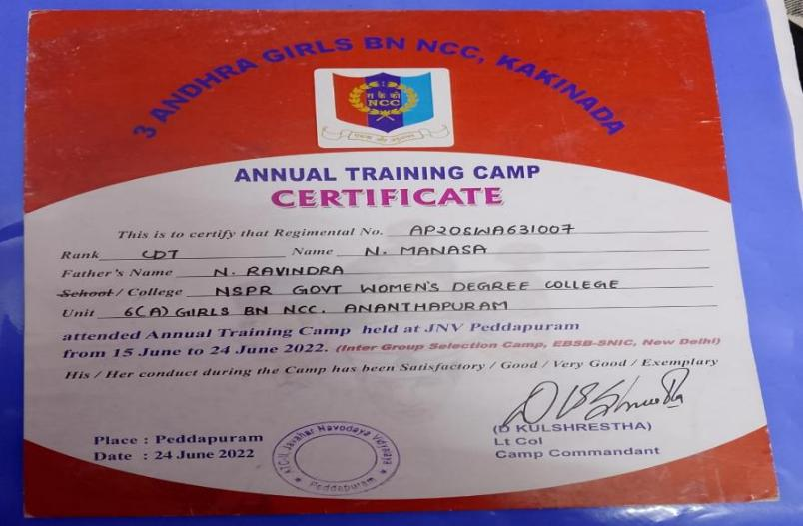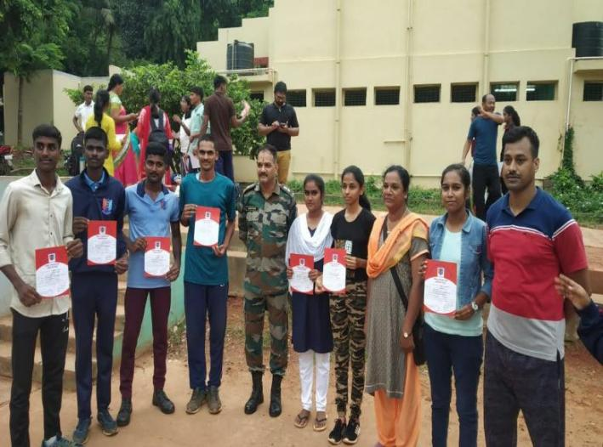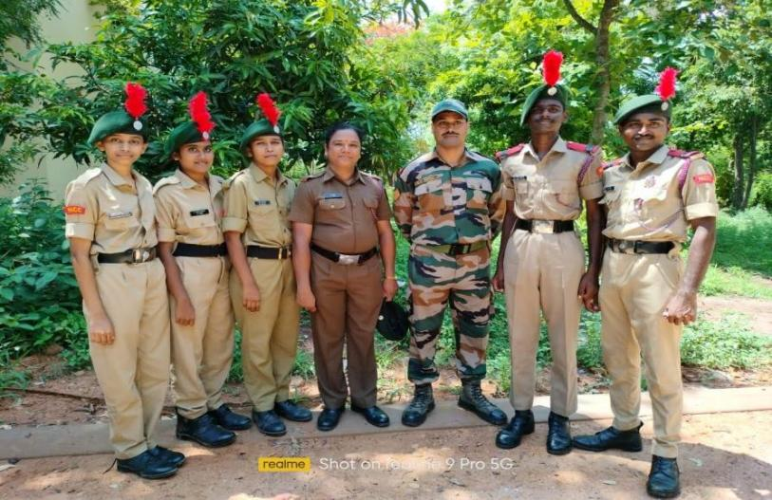

July 2022

Name of the Activity: CATC camp

Date: July 2022

Organised by : 9 Andhra girls BN NCC, Kurnool

Discription : Annual CATC camp held at bramhanapalli anantapur(d) Juniour cadets H. Meghana AP2021631012

and N.Nethravathi AP2021SWA631005 attended the camp Participated in various activitied and games conducted by unit in the camp, they got medals in volly ball and Quater guard

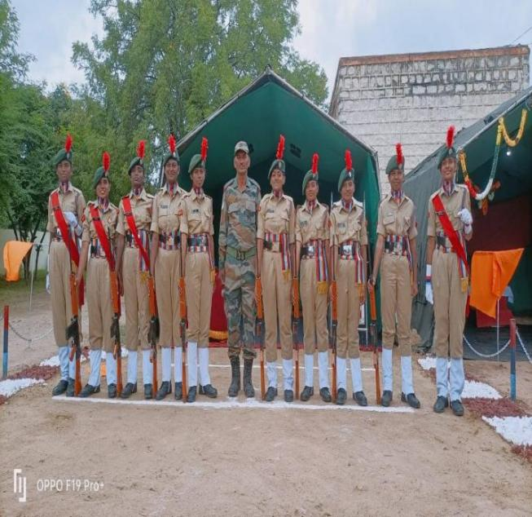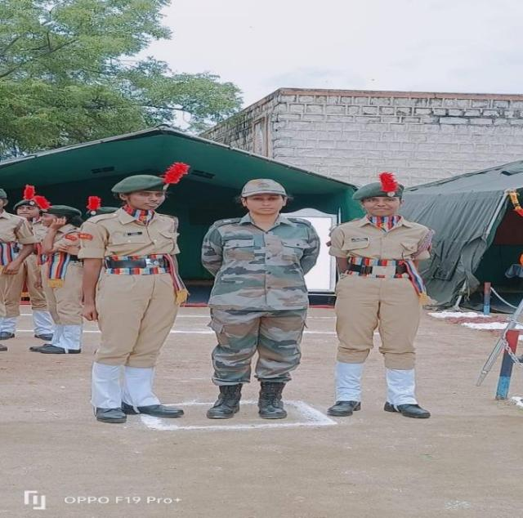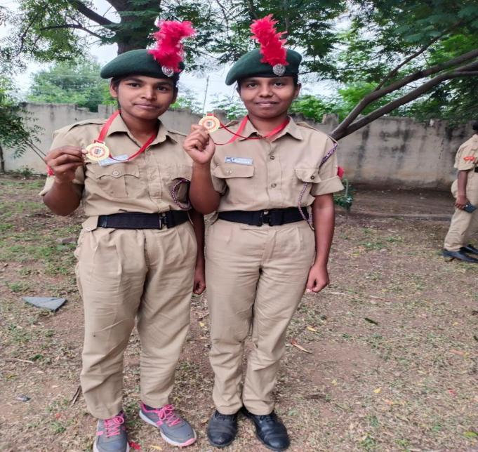

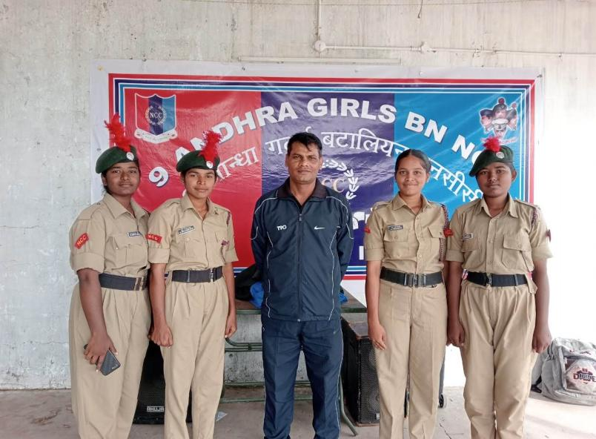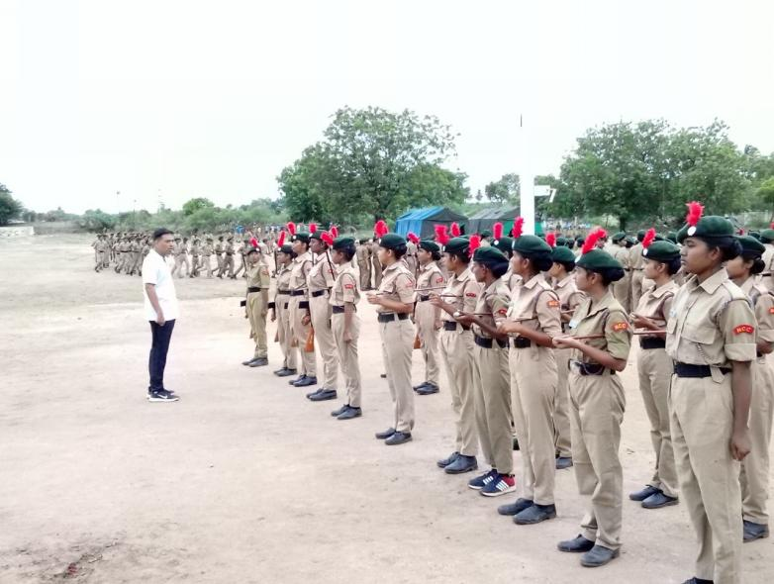

August 2022

Name of the Activity: Independence day parade

Date: 15 August 2022

Organised by :Police Department of Puttaparthy district

Organisers : SP office Puttaparthy

**Discription :** On behalf of independence Day on 15 August As per the Instructions from the Superendent of Police Puttaparthy district NCC Cadets attended for police parade at police ground in Puttaparthy. Our college students 35 members attended for Independence day parade

For this Flag hosting Programme Collector and SP of this district attended and given cerficates to the NCC Cades who are attended for this parade.

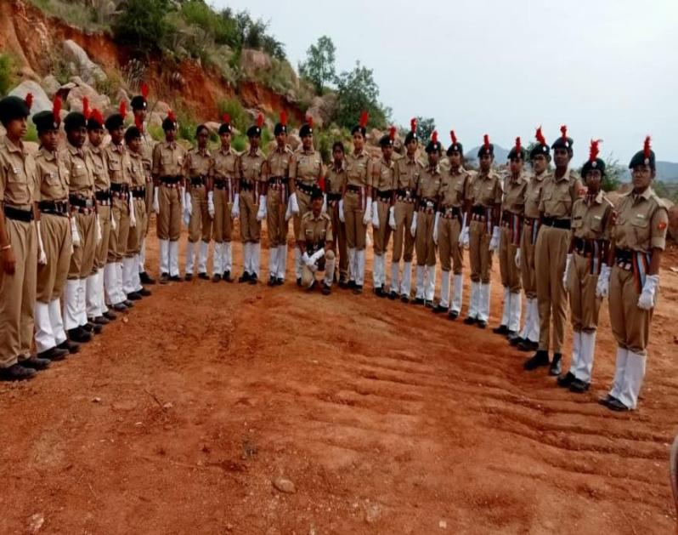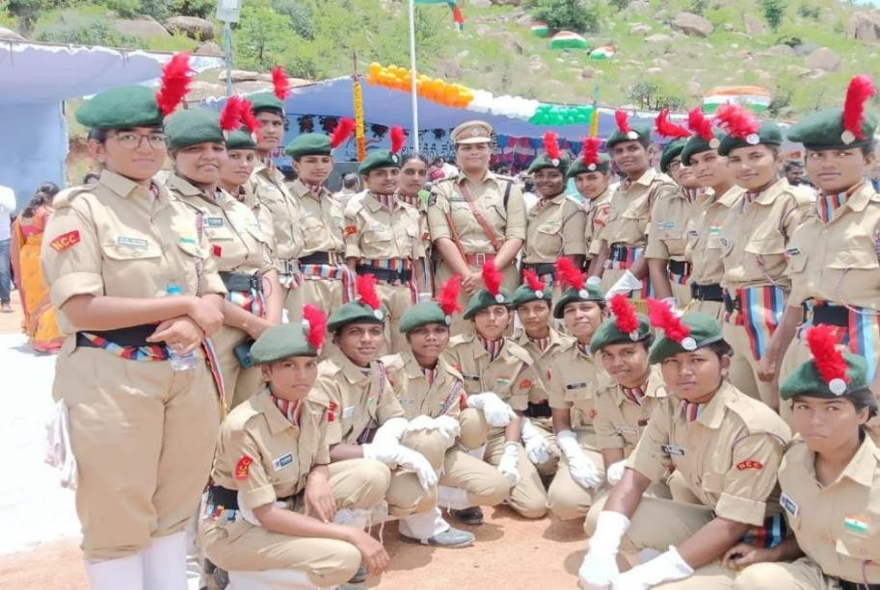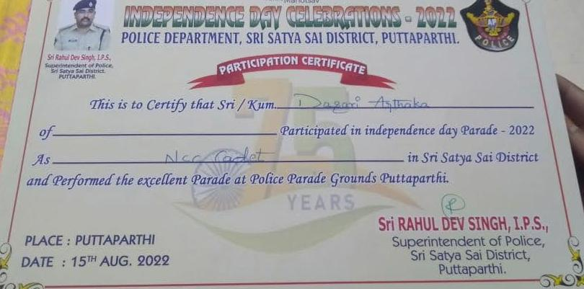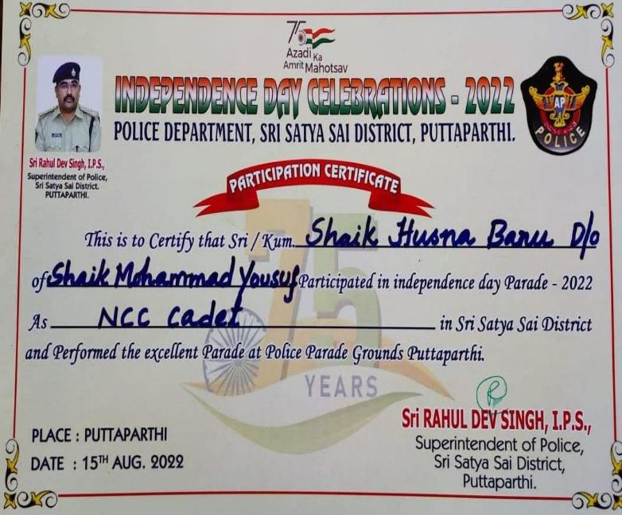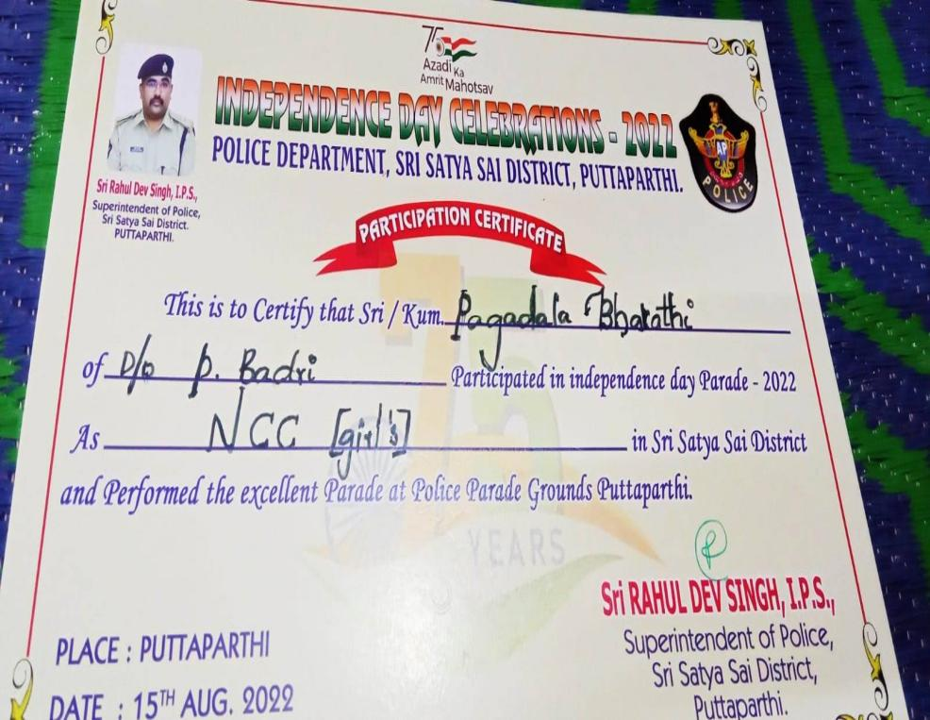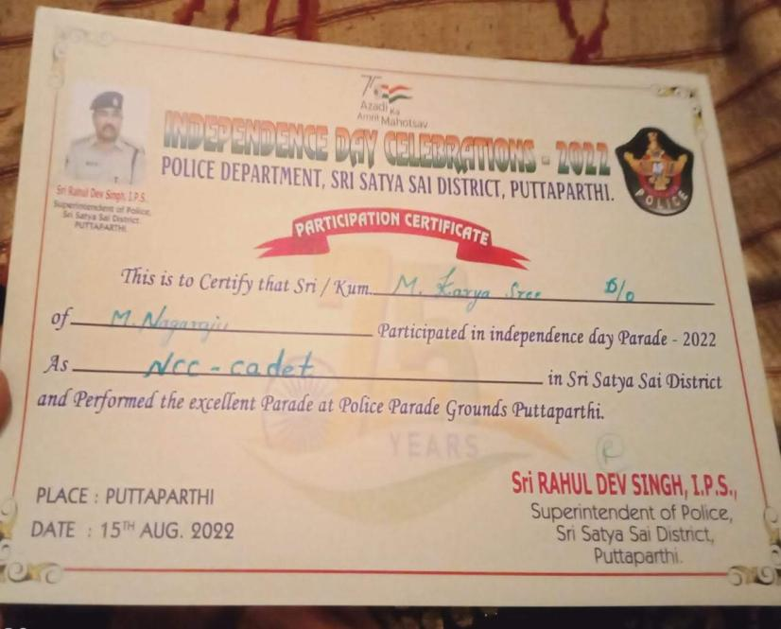

Sep 2022

Name of the Activity: college surroundings cleaning

Date: sep 2022

Organised by : NSPR Degree college

Discription : As per the instructions from NCC unit Anantapur Cleaning Programme conducted in our college surroundings.

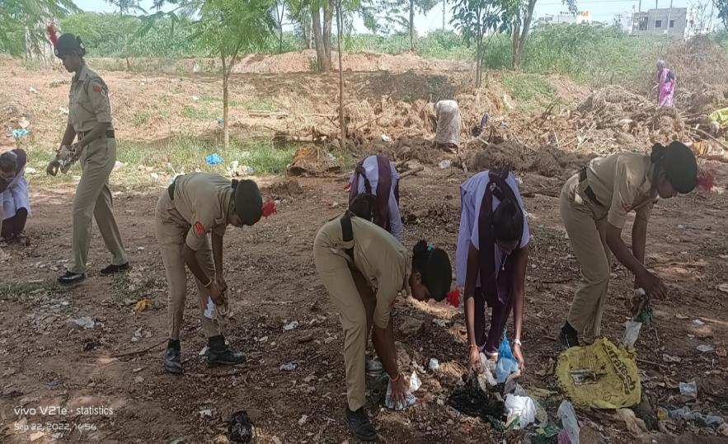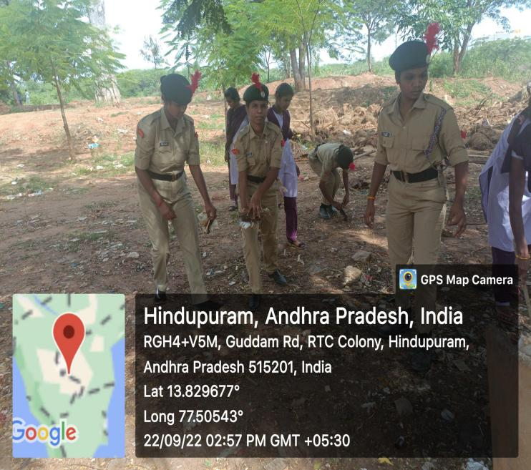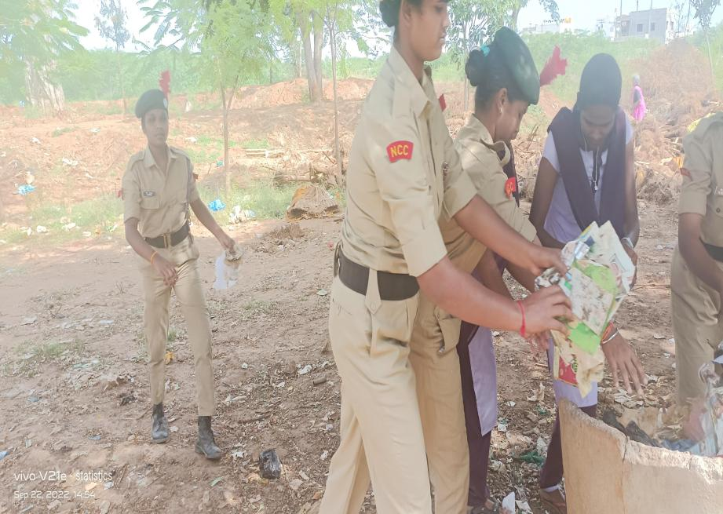

Jan 2023

Name of the Activity: Republic day parade

Date: 26-01-2023

Organised by : Police Department of Puttaparthy district

Organisers : SP office Puttaparthy

No of Participants : 32

**Discription :** On behalf of Republic Day on 26 January As per the Instructions from the Superendent of Police Puttaparthy district NCC Cadets attended for police parade at police ground in Puttaparthy.

For this Flag hosting Programme Collector and SP of this district attended and given cerficates to the NCC Cades who are attended for this parade.

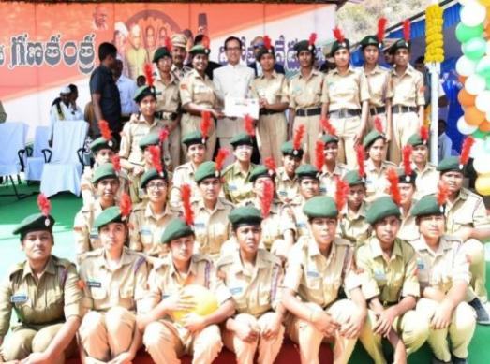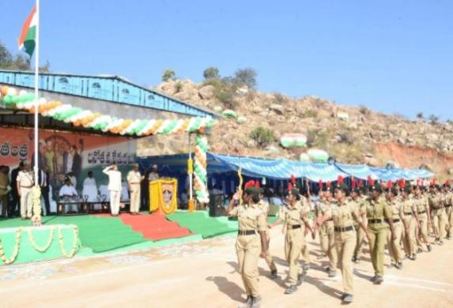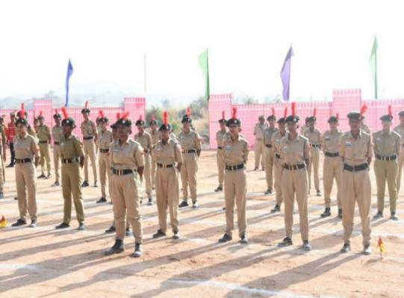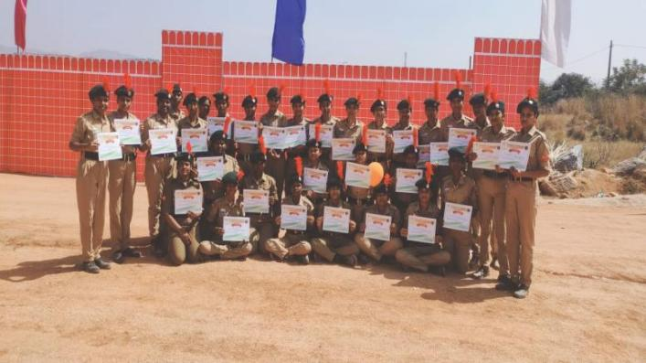

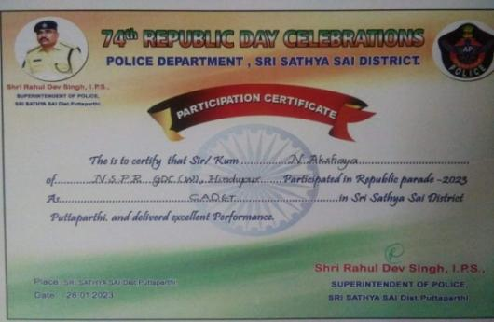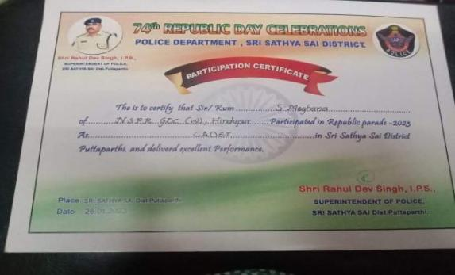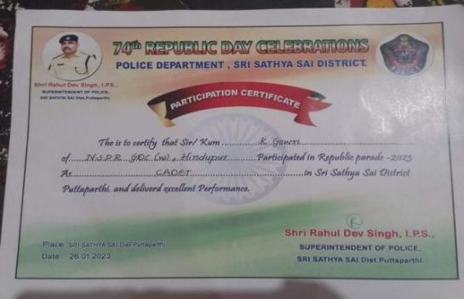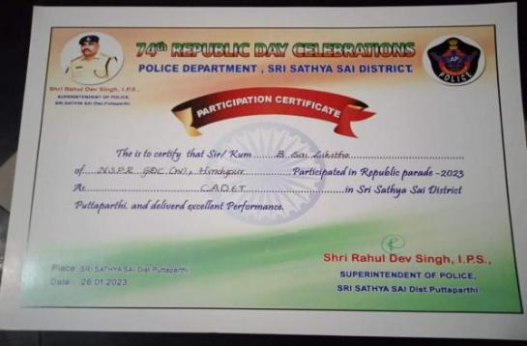

Name of the Activity: NCC Certificates distribution

Date: 26-01-2023

Organised by : NSPR Govt Degree college

Organisers : NCC Unit

No of Participants : 08

Discription : Ncc B Certificates Distributed to NCC Cadets who are passed in ncc B exam held at Anantapur on March 2022 . in this Program Principam Dr. M. Pragathi madem Distributed to Certificates to the students and Ncc CTO C.Sumangali attended the Programme.

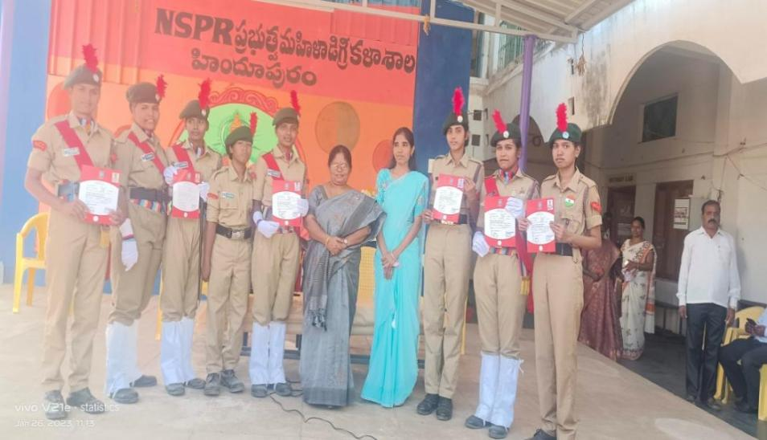 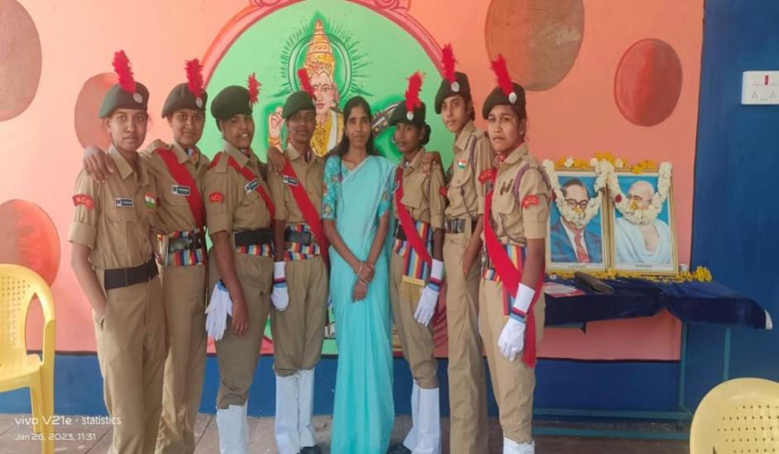

Name of the Activity: NCC c certificate Exam

Date: 16-02-2023

Organised by : ncc

Organisers : 6 andhra bn (g) Anantapur

No of Participants : 07

Discription: Ncc C certificate practical examination was held at police ground in Anantapur 07 cadets from Nspr womens college hindupur attended

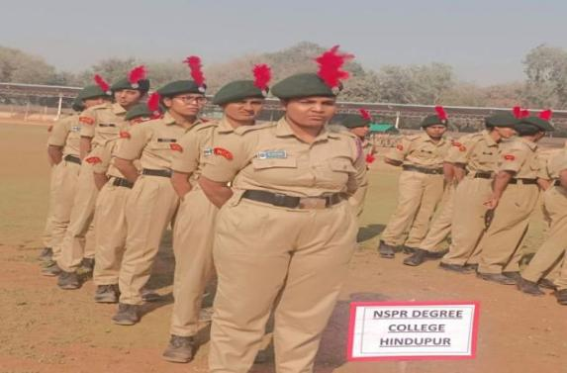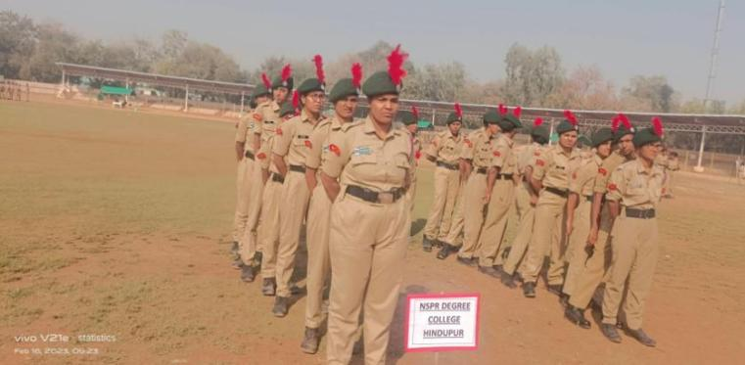 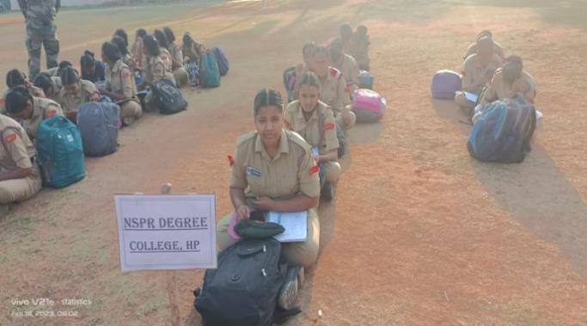

Name of the Activity: NCC c certificate Exam

Date: 19-02-2023

Organised by : ncc

Organisers : 6 andhra bn (g) Anantapur

No of Participants : 07

Discription: Ncc C certificate theory examination was held at kattamanchi ramalingareddy school in Kurnool,

07 cadets from Nspr womens college hindupur attended

